Smoke Flow Visualization

Medam Mahesh

15AE10017

Department of Aerospace Engineering

(B.Tech 3rd Yaar)

Guided By:Prof. Sandeep Saha

**Aim:-**

To visualize flow past cylinder and airfoil using smoke.

**Apparatus:-**

* Wind tunnel
* Models (small cylinder, large cylinder and airfoil)
* Smoke flow setup
* Smoke generator
* Smoke injector

**Theory:-**

Flow visualization is the art of making flow patterns visible. Most fluids (air, water, etc.,) are transparent, thus their flow patterns are invisible to the naked eye without methods to make them visible.

It is of extreme importance before attempting to analyse an aerodynamic flow is to understand the behavior of the flow. This can be done by making the flow visible. The introduction of smoke lines to follow the airflow, allows the investigator to “see” what is happening. These visualizations can then be used to infer the nature of the flow in terms of circulation, vortex effects, flow separations and turbulence. This allows appropriate choices or simplifications of the equations used to solve the flow. Without such visualization, incorrect assumptions will lead to the solution of flow cases that may not be directly relevant to the problem being considered and hence may lead to large errors.

**Smoke Flow Visualization:-**

In this kind of flow visualization, smoke is used to understand the flow characteristics. Smoke flows along the air currents allowing us to visualize the flow. At the intake of the flow, a smoke generator is placed. The smoke enters the test-section as fine lines. Seeing the flow pattern over a body gives a lot of insight in the aerodynamic characteristics of the phenomenon.

Smoke Generator:

Smoke can be generated in a lot of ways like by burning charcoal, leaves, wood etc., or by vaporizing hydrocarbon oils like propylene glycerol or vaporizing oil by a fine wire heated by electric current (smoke-wire technique). Not all smoke can be used for the experiment, it should satisfy the following criteria:

1. Smoke particles must be small enough to define the flow over the surface as the smoke flow.
2. The smoke should not affect the test section and surrounding areas.
3. Smoke should have high reflective properties.
4. Smoke should not be toxic.
5. Smoke should have color that does not match with the surrounding (i.e. the flow should be distinctly visible to the naked eye)

In our experiment, the smoke was made to pass through a series of small vertical tubes (honeycomb-like structure) placed enough far away from the test section.

**Procedure:-**

* The cylindrical model with the smaller radius was placed in the test-section.
* The smoke generator was started and was allowed to settle down in a cascade of chambers comprising of two chamber, one large and other small chamber.
* The suction fan has started and the smoke was drawn in through the injection pipes.
* The cylinder was rotated in order to observe the effects.
* Similar steps were performed on the cylindrical model with larger radius and the airfoil model.
* In case of airfoil, the angle of attack was changed.

**Observations:-**

1. **Cylinder with smaller radius (diameter=15mm):**

* The flow before the cylinder was laminar and steady and flow past was unsteady, vertices being shed alternately from the top and bottom surface in a regular fashion. 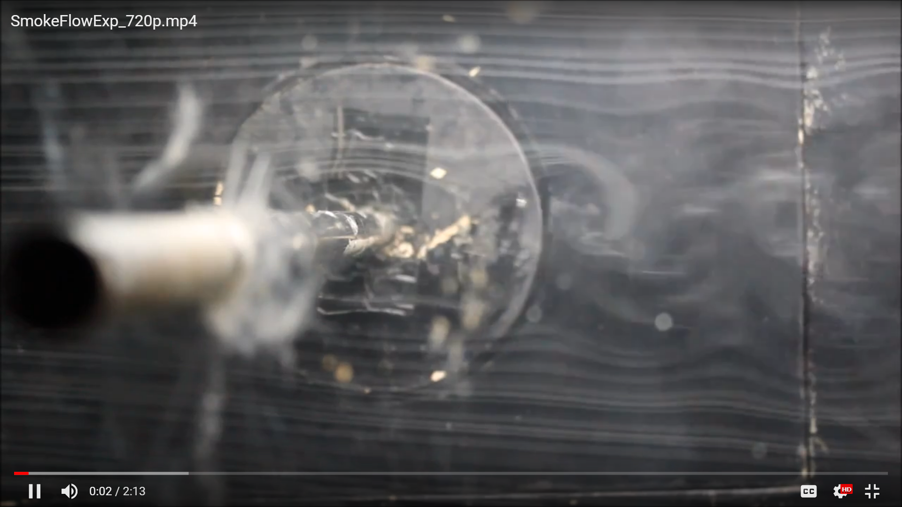
* The eddies grew in size downstream and become weaker as the energy of the vortices is consumed by viscosity as they move further downstream, and the regular pattern disappears. 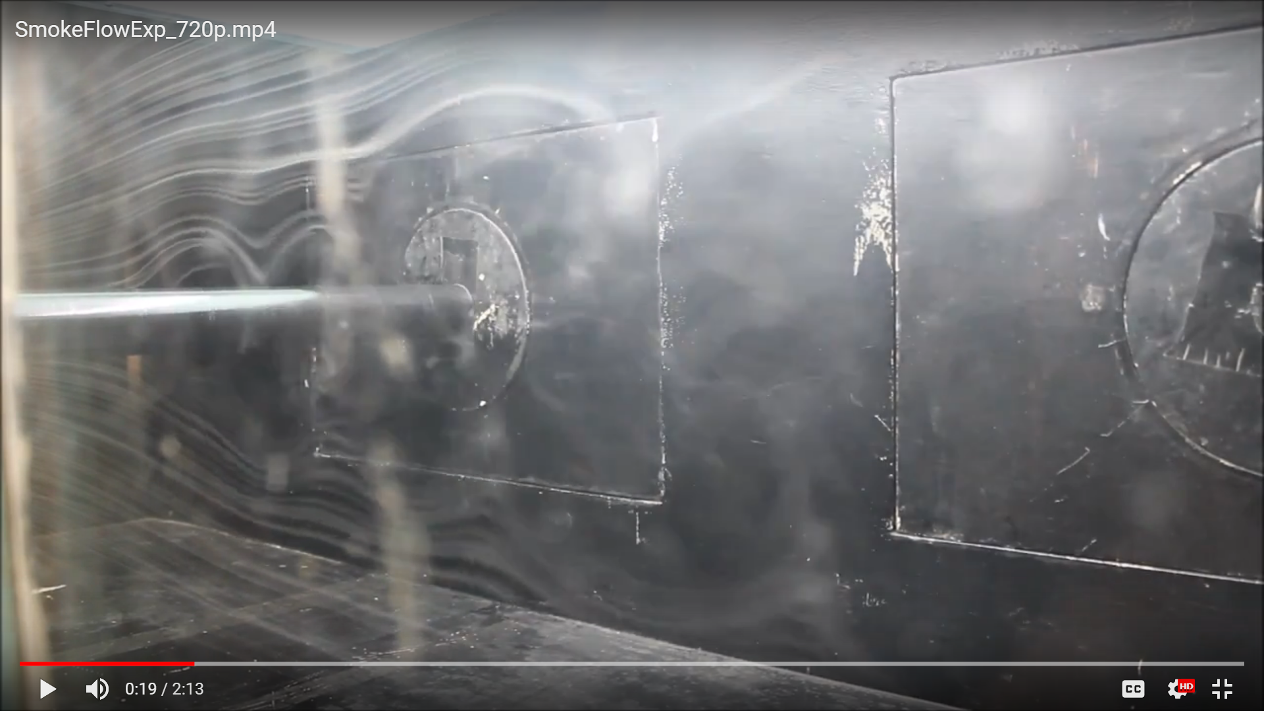
* As flow velocity increases, frequency of production of eddies increases.
* When the cylinder was rotated, the rotation seemed to add/subtract with the vortices, i.e., when the rotation was clockwise, the vortices formed from the upper surface had larger strength while the same formed from the lower surface had lower strength and vice versa.

1. **Cylinder with larger radius (diameter=44.5mm):**

* Due to the increase in radius, the frequency of eddies decreased while the amplitude increased.

1. **Airfoil (Chord=160mm):**

* At 0deg angle of attack, no flow separation was observed.
* But with increase in angle of attack, the flow was still attached but the stagnation point moved backward which initially was at the trailing edge itself.
* After a certain angle of attack, the flow was separated from the surface of the airfoil at a certain point, i.e., the airfoil was stalled. Beyond this point, as angle of attack was increased, the point of separation moved ahead towards the leading edge. Behind the point of separation, a wake was formed. Increasing the angle of attack made the size of the eddies in the wake bigger.
* In the case of negative angle of attack, the flow separated from the lower surface of the airfoil, as opposed to the upper surface as observed in the case of positive angle of attack. Again, trailing edge vortices were formed after flow separation which grew bigger as the angle was decreased to even a lower value.

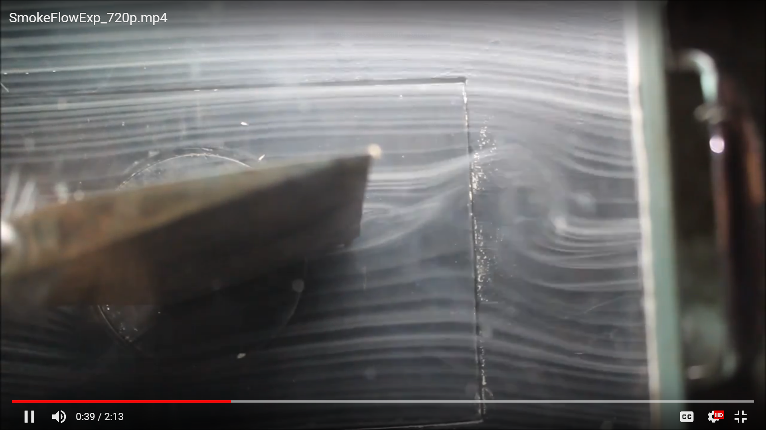

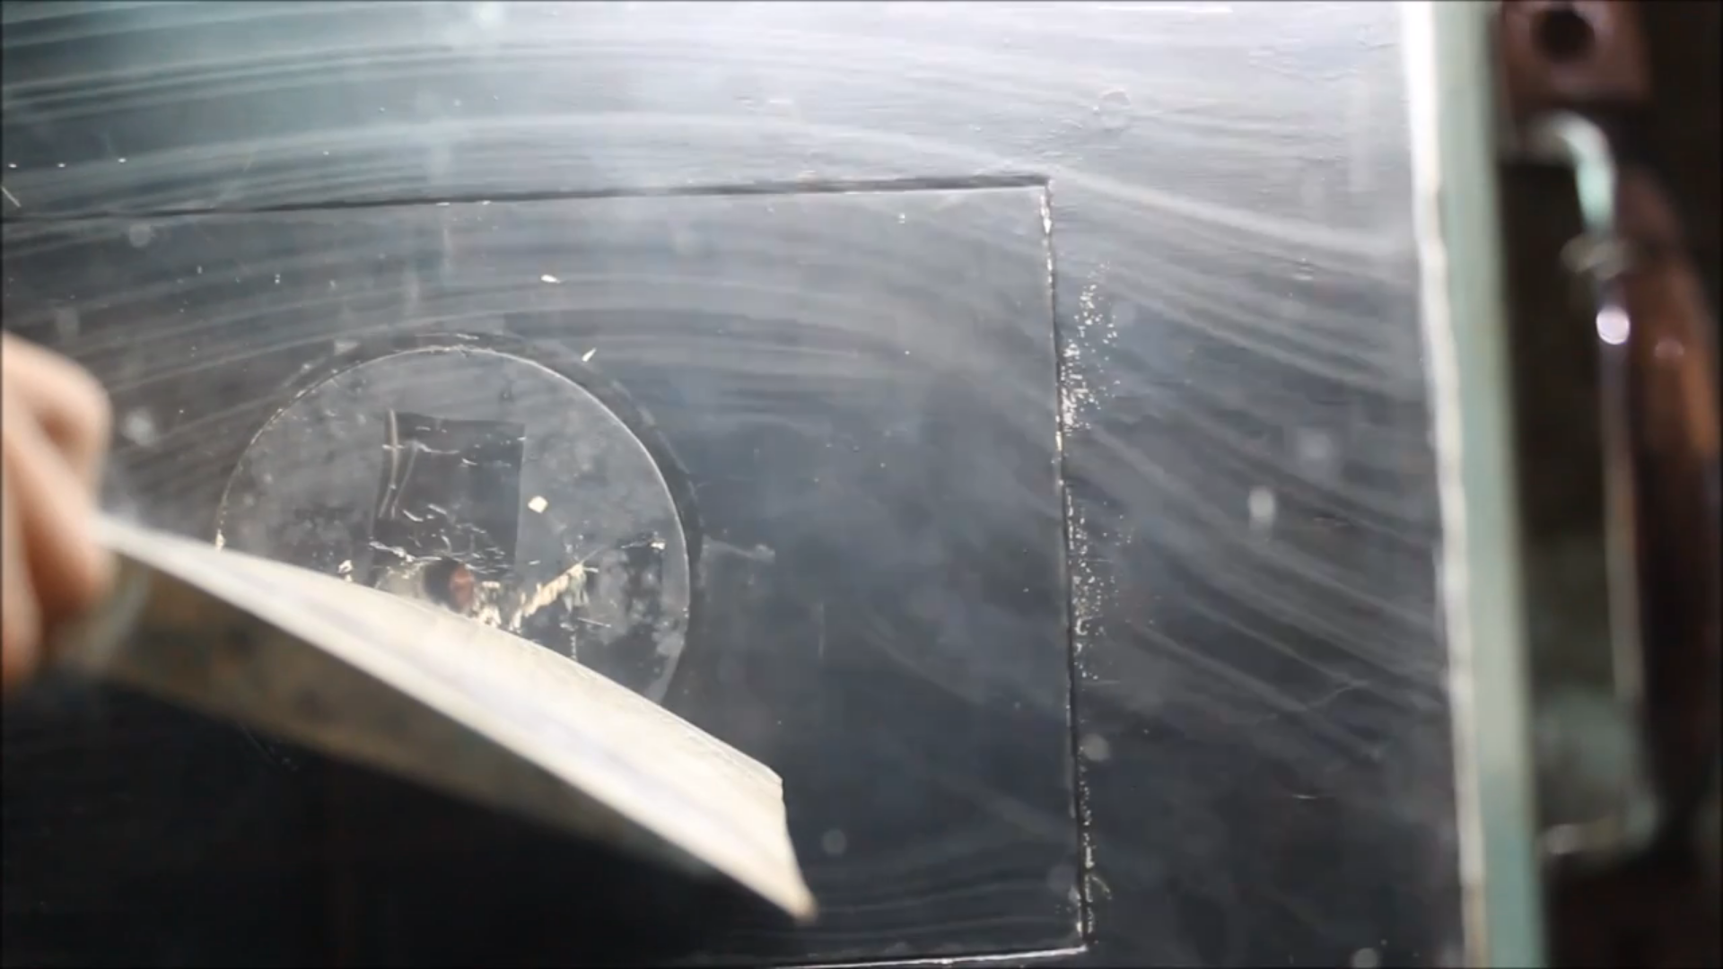

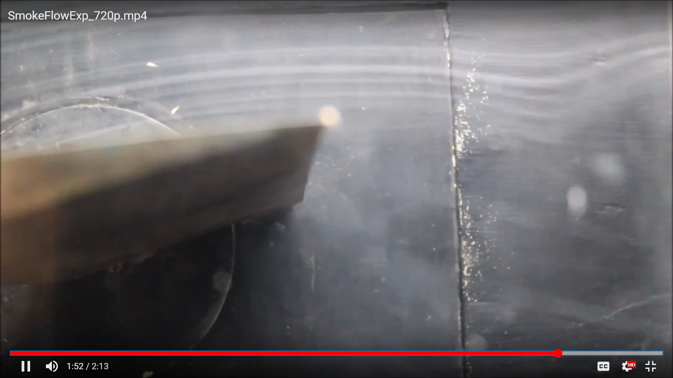

**Discussions:-**

**(i) Different methods of flow visualization :-**

In experimental fluid dynamics, flows are visualized by three methods:

Surface flow visualization: This reveals the flow streamlines in the limit as a solid surface is approached. Colored oil applied to the surface of a wind tunnel model provides one example (the oil responds to the surface shear stress and forms a pattern).

Particle tracer methods: Particles, such as smoke or microspheres, can be added to a flow to trace the fluid motion. We can illuminate the particles with a sheet of laser light in order to visualize a slice of a complicated fluid flow pattern. Assuming that the particles faithfully follow the streamlines of the flow, we can not only visualize the flow but also measure its velocity using the particle image Velocimetry or particle tracking Velocimetry methods. Particles with densities that match that of the fluid flow will exhibit the most accurate visualization.

Optical methods: Some flows reveal their patterns by way of changes in their optical refractive index. These are visualized by optical methods known as the shadowgraph, schlieren photography, and interferometry. More directly, dyes can be added to (usually liquid) flows to measure concentrations; typically employing the light attenuation or laser-induced fluorescence techniques.

**(ii) Advantages and Disadvantages of smoke flow visualization:-**

a. Advantages:-

• Easy setup

• Quick repositioning of the probe allows for viewing flow patterns around any portion of the model.

b. Disadvantages :-

• Extended use fills the tunnel with smoke. The tunnel must be vented to remove the smoke before further flow visualization can be used. An oily residue is left on whatever the smoke touches. Furthermore, pressure taps must be protected to prevent clogging.

**(iii) Smoke Flow Lines in the experiment:-**

The smoke flow lines in the experiment were streaklines. Streaklines are the locus of points originating from a single point in the past.

**(iv) Non-Bernoulli Flow:-**

Bernoulli Flow is applicable to flows which are irrotaional and inviscid. But, here we see the formation of vortices for all of the models. This means the curl of velocity is non-zero. Thus, the flow is not irrotational. Hence, Bernoulli theorem can not be applied on this flow.

**(v) Vortices over the cylinder:-**

The vortices formed in case of cylinder were alternate vortices from the upper and lower surfaces. This is called Karman Vortex Sheet.

As the flow goes farther past the model, the eddies grow larger and weaker and hence losing their vortex structure.

**(vi) Vortices over the airfoil:-**

In case of airfoil, the vortices are formed according to the Kelvins Circulations Theorem. According to this circulation around a closed curve which encloses the same fluid element moving with the fluid, remain constant with time. Thus if a vortex element is present in the fluid domain, it cannot end in it. We know that there exists a **bound vortex** in an airfoil. Since, when the flow started, there was no circulation present in the fluid domain, thus to counter the above there exists a vortex filament with opposite sense of rotation.